Experiment 1

Aim : Design and Implementation using Substitution ciphers : Caesar Cipher, Auto Key Cipher, Playfair Cipher.

Theory:-

Caesar Cipher :

The simplest and oldest type of encryption is the Caesar cipher. The Caesar cipher technique, often known as a shift cipher or additive cipher, is predicated on a mono-alphabetic cipher. per letter in plain text is swapped out for a different letter per set number of shifts.
A right shift of three, for instance, would cause A to become D, S to become V, and so forth.

Encryption:-
def caesar_cipher(text, shift):
result = ""
for char in text:
if char.isalpha():
is_upper = char.isupper()
shifted_char = chr((ord(char) - ord('A' if is_upper else 'a') + shift) % 26 + ord('A' if is_upper else 'a'))
result += shifted_char
else:
result += char
return result
plaintext = input("Enter the plaintext: ")
shift_value = int(input("Enter the shift value: "))
ciphertext = caesar_cipher(plaintext, shift_value)

print(f"Ciphertext: {ciphertext}")

Output:
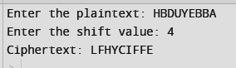

Caesar Cipher : Decryption

def caesar_decipher(ciphertext, shift):
result = ""
for char in ciphertext:
if char.isalpha():
is_upper = char.isupper()
shifted_char = chr((ord(char) - ord('A' if is_upper else 'a') - shift) % 26 + ord('A' if is_upper else 'a'))
result += shifted_char
else:
result += char
return result
ciphertext = input("Enter the ciphertext: ")
shift_value = int(input("Enter the shift value: "))
decrypted_text = caesar_decipher(ciphertext, shift_value)

print(f"Decrypted Text: {decrypted_text}")
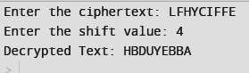

Auto Key Cipher :

The Autokey Cipher encrypts plaintext messages using a key in a polyalphabetic substitution method. Every character in the plaintext message is encrypted using a unique combination of letters and numbers that make up the key. The plaintext message's length is equal to or greater than the key's length.
Using "KEYHE" as the repeated key, for instance, to encrypt "HELLO" with the key "KEY" would produce a ciphertext similar to "RIJVS."

Encryption

class AutoKeyCipher:
def __init__(self, key, plain_text):
self.uppercase = "ABCDEFGHIJKLMNOPQRSTUVWXYZ"
self.lowercase = "abcdefghijklmnopqrstuvwxyz"
self.key = key
self.plain_text = plain_text
self.cipher = []
def encrypt(self):
for i in range(len(self.plain_text)):
ch = self.plain_text[i]
if not ch.isalpha():
self.cipher.append(ch)
continue
if i > 0:
prev = self.plain_text[i - 1]
self.key = ord(prev) - (ord('A') if prev.isupper() else ord('a'))
if ch.isupper():
ciphered = (ord(ch) - ord('A') + self.key) % 26
self.cipher.append(self.uppercase[ciphered])
else:
ciphered = (ord(ch) - ord('a') + self.key) % 26
self.cipher.append(self.lowercase[ciphered])
def get_encrypted_text(self):
return ''.join(self.cipher)
def main():
key = int(input("Enter the key for AutoKey cipher: "))
data = input("Enter the plaintext: ")
cc = AutoKeyCipher(key, data)
cc.encrypt()
encrypted_text = cc.get_encrypted_text()
print("Encrypted Text:", encrypted_text)
if __name__ == "__main__":
main()

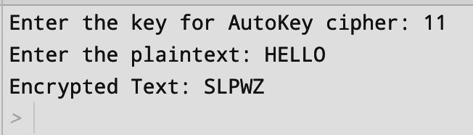

Auto Key Cipher : Decryption

class AutoKeyCipher:
def __init__(self, key, cipher_text):
self.uppercase = "ABCDEFGHIJKLMNOPQRSTUVWXYZ"
self.lowercase = "abcdefghijklmnopqrstuvwxyz"
self.key = key
self.cipher_text = cipher_text
self.plain_text = []
def decrypt(self):
for i in range(len(self.cipher_text)):
ch = self.cipher_text[i]
if not ch.isalpha():
self.plain_text.append(ch)
continue
if i > 0:
prev = self.plain_text[i - 1]
self.key = ord(prev) - (ord('A') if prev.isupper() else ord('a'))
if ch.isupper():
deciphered = (ord(ch) - ord('A') - self.key) % 26
self.plain_text.append(self.uppercase[deciphered])
else:
deciphered = (ord(ch) - ord('a') - self.key) % 26
self.plain_text.append(self.lowercase[deciphered])
def get_decrypted_text(self):
return ''.join(self.plain_text)
def main():
key = int(input("Enter the key for AutoKey cipher: "))
data = input("Enter the ciphertext: ")
cc = AutoKeyCipher(key, data)
cc.decrypt()
decrypted_text = cc.get_decrypted_text()
print("Decrypted Text:", decrypted_text)
if __name__ == "__main__":
main()

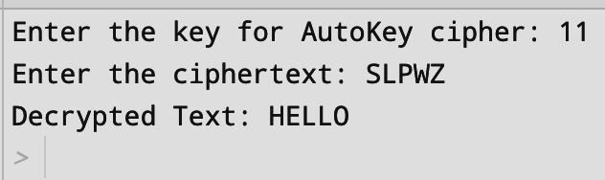

PlayFair Cipher :

A message can be encoded or encrypted using the Playfair Cipher encryption method.
It functions precisely like standard encryption. The encryption of a digraph—two letters—rather than a single letter is the only distinction.A 5x5 matrix key table is first built. The alphabetic characters in the matrix make up the plaintext encryption key.
Remember that you shouldn't say the letters more than once. There are 26 alphabets, yet there are only 25 spots available for letters to be placed. There is an excess of one character (usually J), thus the matrix will remove the additional letter. Notwithstanding this, J appears in the plaintext prior to being altered to I.

Encryption and Decryption

def playfair_cipher(plaintext, key, mode):
alphabet = 'abcdefghiklmnopqrstuvwxyz'
key = key.lower().replace(' ', '').replace('j', 'i')
key_square = ''
for letter in key + alphabet:
if letter not in key_square:
key_square += letter
plaintext = plaintext.lower().replace(' ', '').replace('j', 'i')
if len(plaintext) % 2 == 1:
plaintext += 'x'
digraphs = [plaintext[i:i+2] for i in range(0, len(plaintext), 2)]
def encrypt(digraph):
a, b = digraph
row_a, col_a = divmod(key_square.index(a), 5)
row_b, col_b = divmod(key_square.index(b), 5)
if row_a == row_b:
col_a = (col_a + 1) % 5
col_b = (col_b + 1) % 5
elif col_a == col_b:
row_a = (row_a + 1) % 5
row_b = (row_b + 1) % 5
else:
col_a, col_b = col_b, col_a
return key_square[row_a * 5 + col_a] + key_square[row_b * 5 + col_b]
def decrypt(digraph):
a, b = digraph
row_a, col_a = divmod(key_square.index(a), 5)
row_b, col_b = divmod(key_square.index(b), 5)
if row_a == row_b:
col_a = (col_a - 1) % 5
col_b = (col_b - 1) % 5
elif col_a == col_b:
row_a = (row_a - 1) % 5
row_b = (row_b - 1) % 5
else:
col_a, col_b = col_b, col_a
return key_square[row_a * 5 + col_a] + key_square[row_b * 5 + col_b]
result = ''
for digraph in digraphs:
if mode == 'encrypt':
result += encrypt(digraph)
elif mode == 'decrypt':
result += decrypt(digraph)
return result

plaintext_input = input("Enter the plaintext: ")
key_input = input("Enter the key: ")

ciphertext = playfair_cipher(plaintext_input, key_input, 'encrypt')
print("Ciphertext:", ciphertext)

decrypted_text = playfair_cipher(ciphertext, key_input, 'decrypt')
print("Decrypted Text:", decrypted_text)

Output:

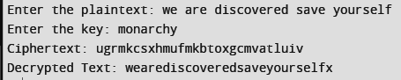

Conclusion : -
Substitution ciphers have been employed throughout history as a fundamental tool in the field of cryptography, with notable examples such as the Caesar cipher and the Atbash cipher. While these methods offer a simple yet effective means of obscuring the content of a message, they may be susceptible to cryptanalysis techniques, such as frequency analysis.The use of substitution ciphers extends beyond traditional communication, finding applications in various fields, including computer security, where they are employed to protect sensitive data and ensure the integrity of digital information. As technology evolves, so does the need for robust encryption methods, making the study of substitution ciphers an essential component of cryptographic education and practice.

